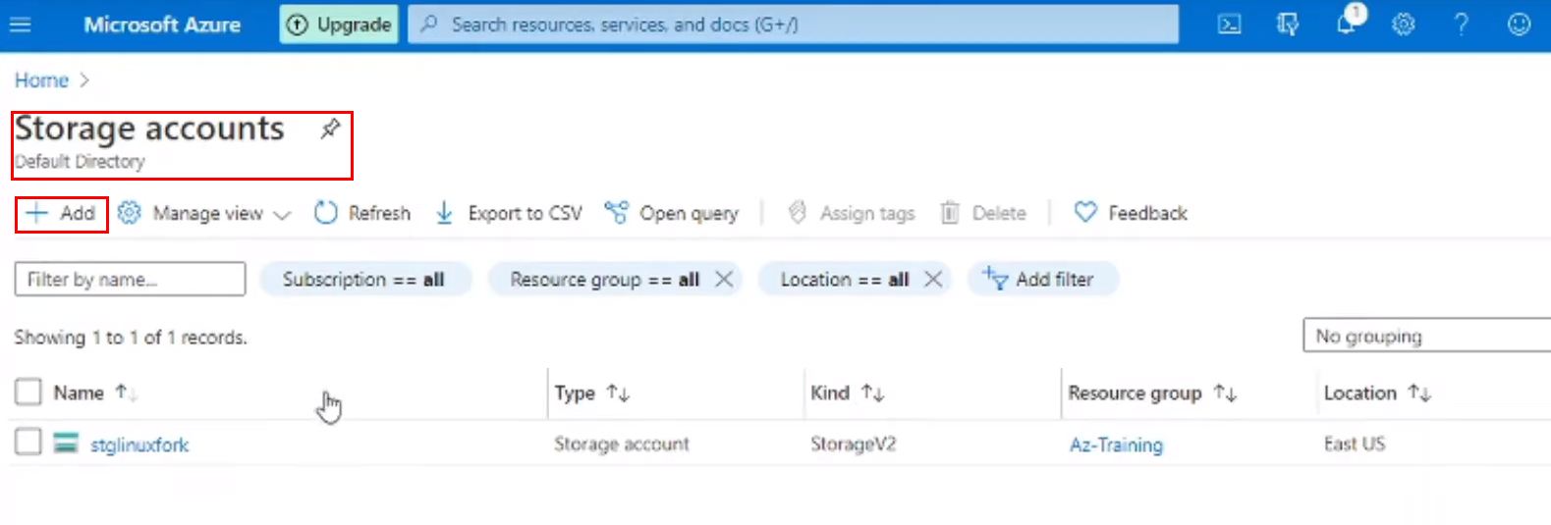

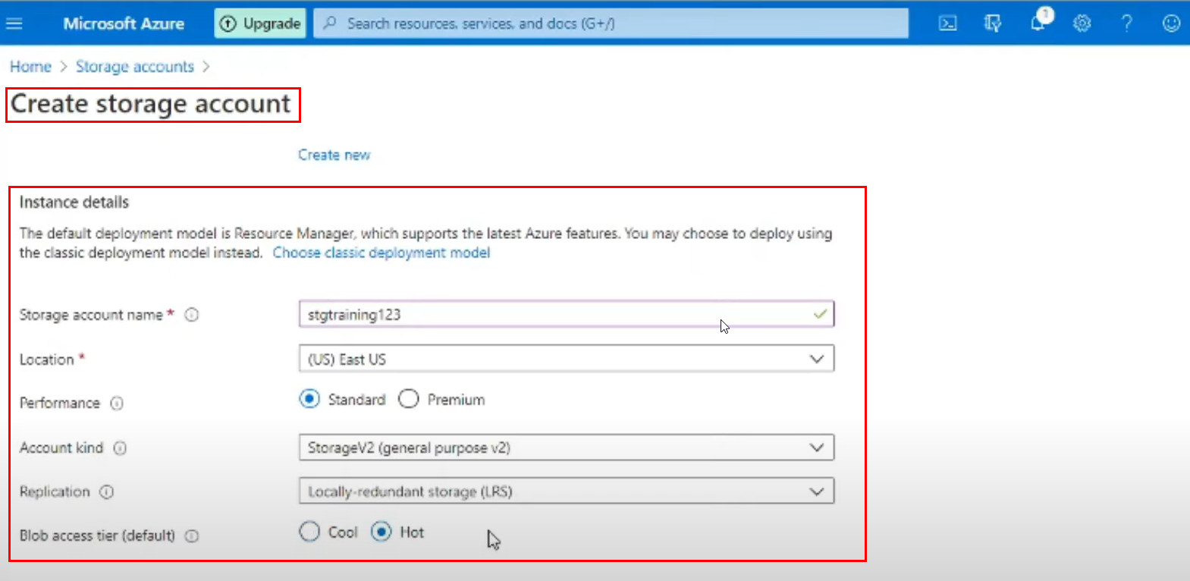

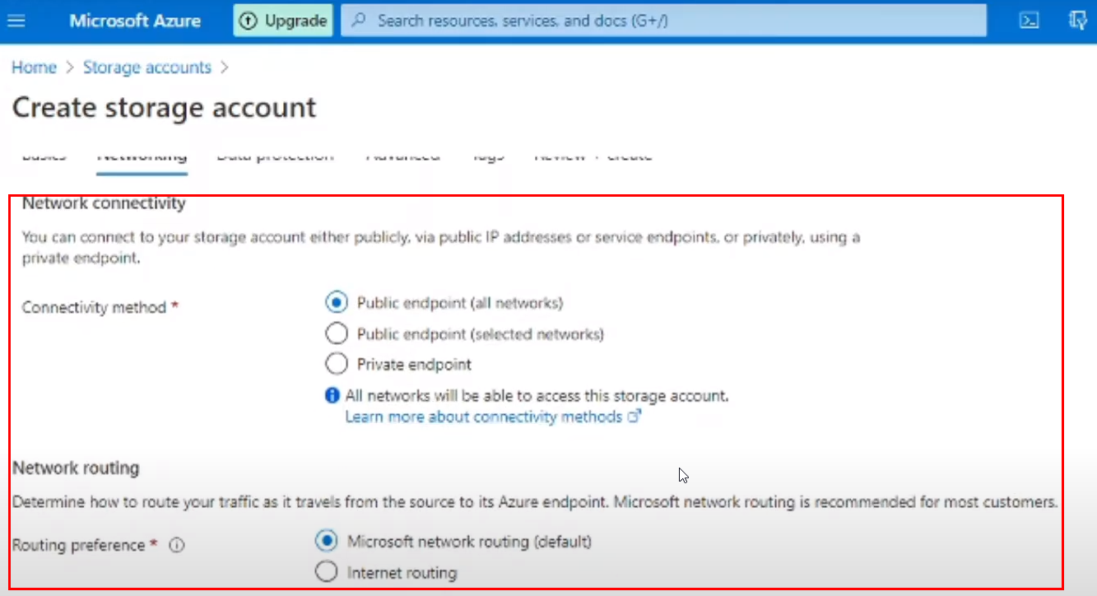

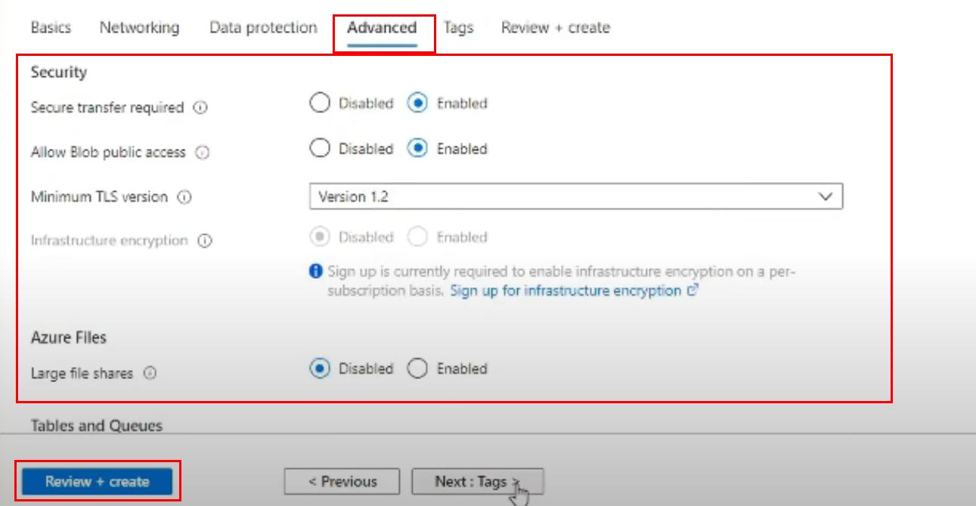

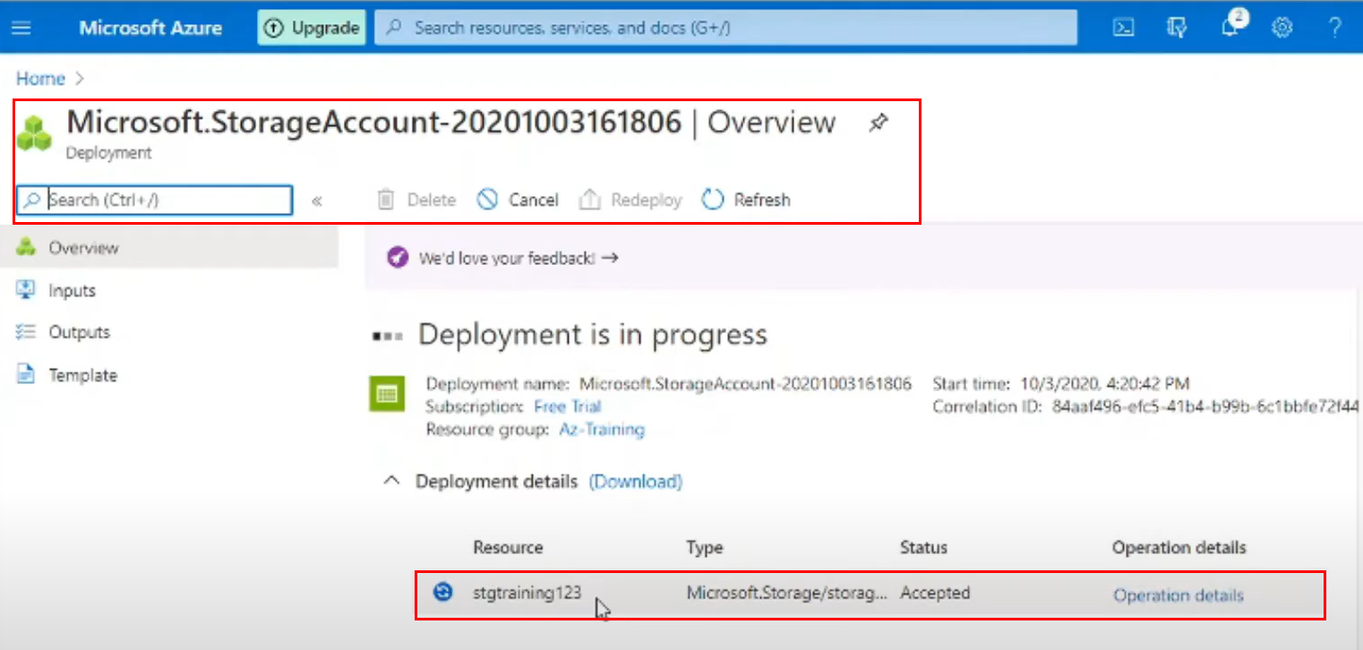

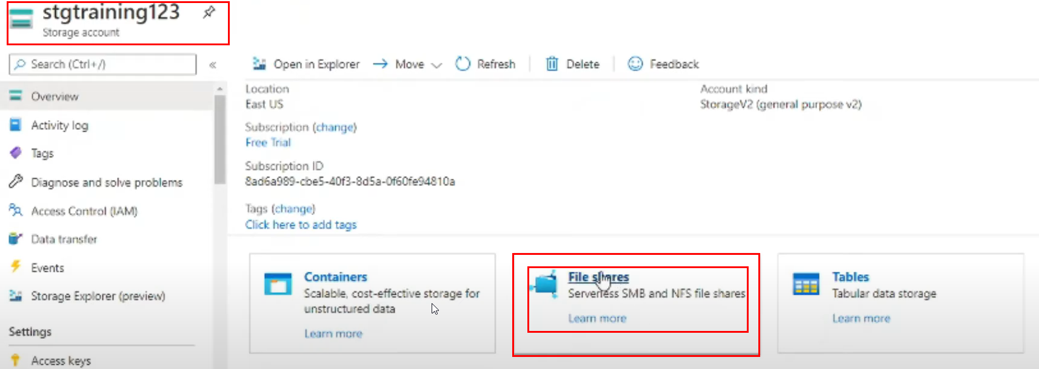

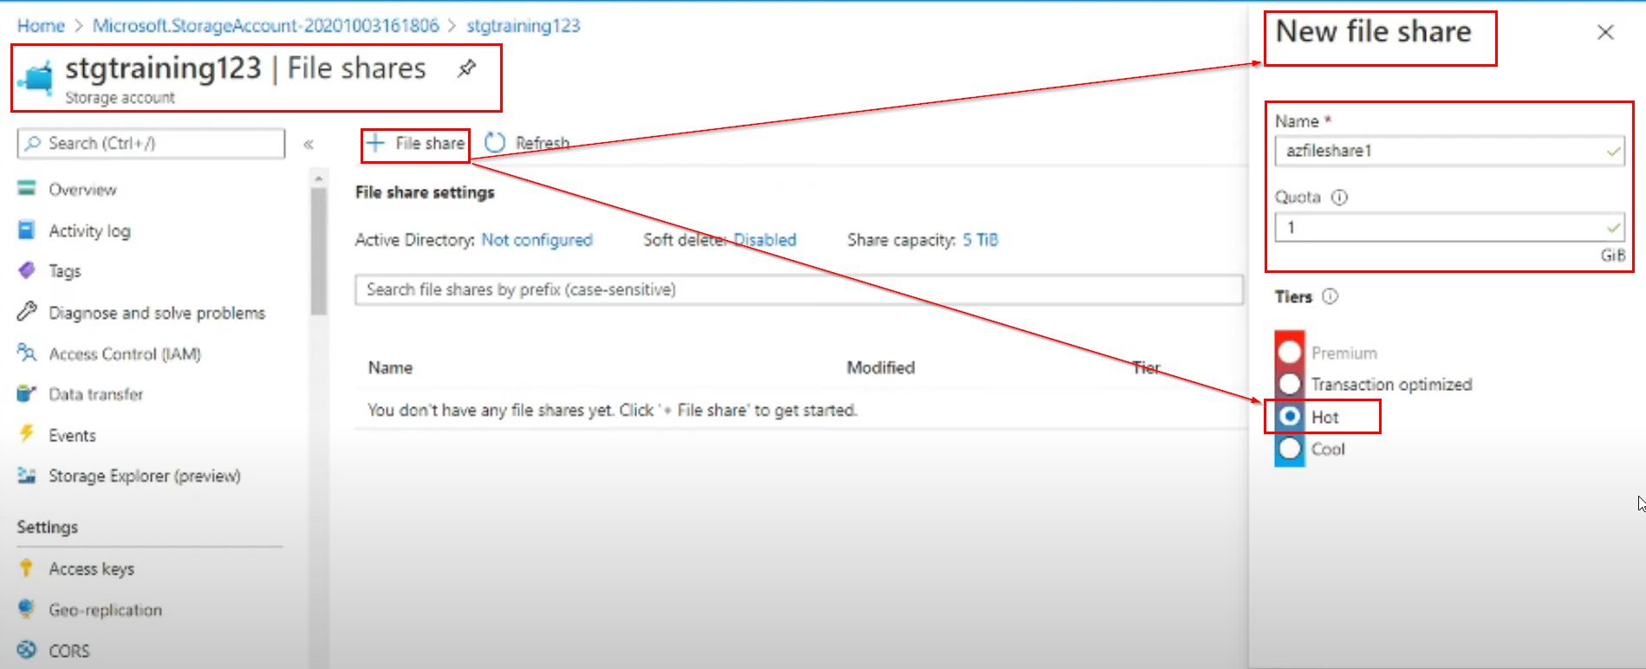

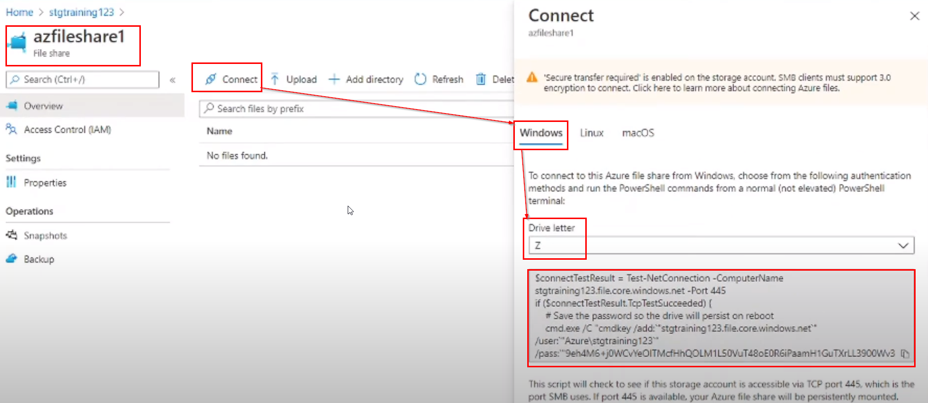

**: PowerShell Script for Mounting in Windows 10 PC :**

$connectTestResult = Test-NetConnection -ComputerName  
stgtraining123file.core.windows.net -Port 445  
if($connectTestResult.TcpTestSucceeded) {  
 # Save the password so the drive will persist on reboot  
 cmd.exe /C “cmdkey /add:`stgtraining123.file.core.windows.net`”  
/user: `“Azure\stgtraining123”`  
/pass: `“asdasdbkjTQTFUVP{KOPKOKBVBN%8q&^5^&habs*^%^&%HABHVghgavdh  
asdasdbkjTQTFUVP{KOPKOKBVBN%8q&^5^&habs*^%^&%HABHVghgavdh asdasdbkjTQTFUVP{KOPKOKBVBN%8q&^5^&habs*^%^&%HABHVghgavdh asdasdbkjTQTFUVP{KOPKOKBVBN%8q&^5^&habs*^%^&%HABHVghgavdh asdasdbkjTQTFUVP{KOPKOKBVBN%8q&^5^&habs*^%^&%HABHVghgavdh asdasdbkjTQTFUVP{KOPKOKBVBN%8q&^5^&habs*^%^&%HABHVghgavdh asdasdbkjTQTFUVP{KOPKOKBVBN%8q&^5^&habs*^%^&%HABHVghgavdh”`   
}

**: Bash Script for Mounting in any Linux PC :**

